Lab 4.6.3: Troubleshooting Security Configuration (Solution)

Topology Diagram
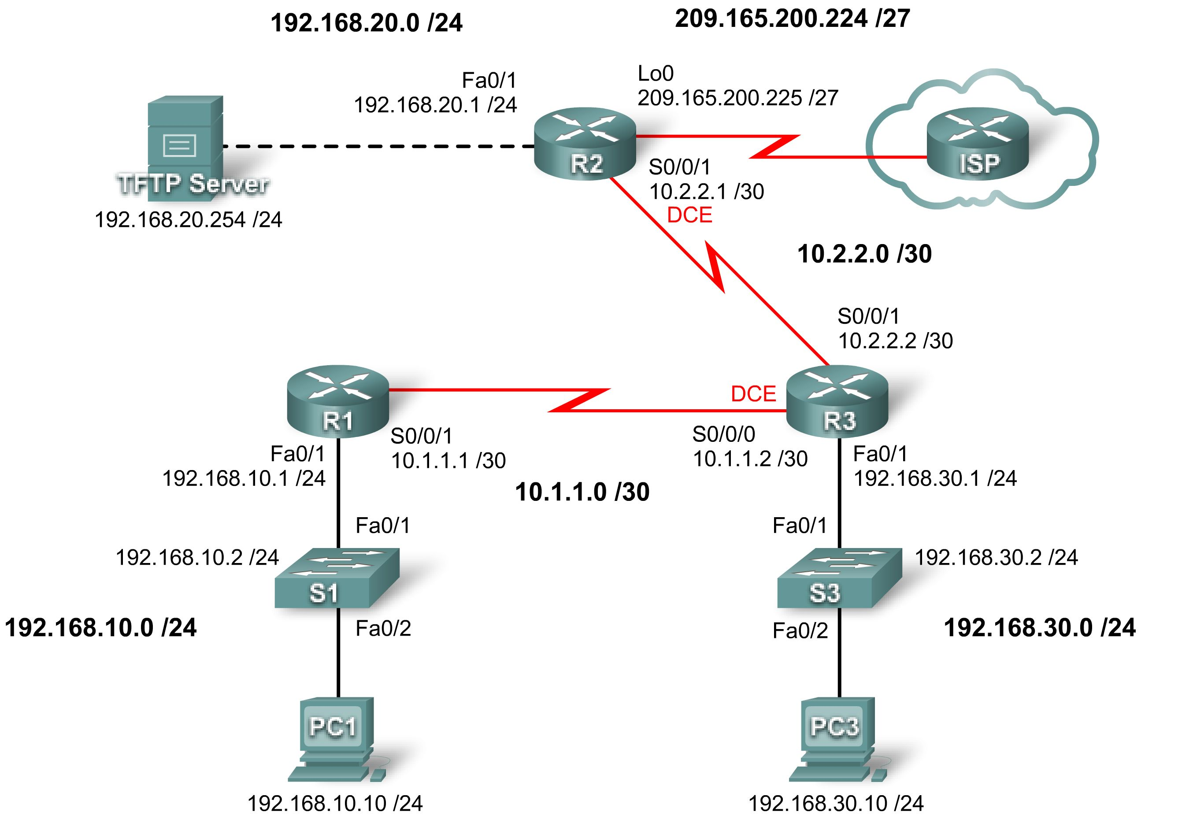

Addressing Table
Device | Interface | IP Address | Subnet Mask | Default Gateway
R1 | Fa0/1 | 192.168.10.1 | 255.255.255.0 | N/A
R1 | S0/0/1 | 10.1.1.1 | 255.255.255.252 | N/A
R2 | Fa0/1 | 192.168.20.1 | 255.255.255.0 | N/A
R2 | S0/0/1 | 10.2.2.1 | 255.255.255.252 | N/A
R2 | Lo0 | 209.165.200.225 | 255.255.255.224 | N/A
R3 | Fa0/1 | 192.168.30.1 | 255.255.255.0 | N/A
R3 | S0/0/1 | 10.2.2.2 | 255.255.255.252 | N/A
R3 | S0/0/0 | 10.1.1.2 | 255.255.255.252 | N/A
S1 | VLAN10 | 192.168.10.2 | 255.255.255.0 | N/A
S3 | VLAN30 | 192.168.30.2 | 255.255.255.0 | N/A
PC1 | NIC | 192.168.10.10 | 255.255.255.0 | 192.168.10.1
PC3 | NIC | 192.168.30.10 | 255.255.255.0 | 192.168.30.1
TFTP Server | NIC | 192.168.20.254 | 255.255.255.0 | 192.168.20.1

Learning Objectives
Upon completion of this lab, you will be able to:
- Cable a network according to the topology diagram.
- Erase the startup configuration and restore all routers to the default state.
- Load routers with supplied scripts.
- Find and correct all network errors.
- Document the corrected network.

Scenario
Your company just hired a new network engineer who has created some security issues in the network with misconfigurations and oversights. Your boss has asked you to correct the errors the new engineer has made configuring the routers. While correcting the problems, make sure that all the devices are secure but are still accessible by administrators, and that all networks are reachable. All routers must be accessible with SDM from PC1. Verify that a device is secure by using tools such as Telnet and ping. Unauthorized use of these tools should be blocked, but also ensure that authorized use is permitted. For this lab, do not use login or password protection on any console lines to prevent accidental lockout. Use ciscoccna for all passwords in this scenario.
Task 1: Load Routers with the Supplied Scripts
Load the following configurations into the devices in the topology. Each line in red is not loaded into the router at the beginning of this lab. Lines to be removed are highlighted in yellow. Lines to be added are in red.
R1:
no service pad
service timestamps debug datetime msec
service timestamps log datetime msec
service password-encryption
!
hostname R1
!
boot-start-marker
boot-end-marker
!
security authentication failure rate 10 log
security passwords min-length 6
enable secret ciscoccna
!
aaa new-model
!
aaa authentication login LOCAL_AUTH local
aaa authentication login local_auth local
!
Case-sensitive names can create common configuration errors. Here the policy should be lowercase.

aaa session-id common
!
resource policy
!
mmi polling-interval 60
no mmi auto-configure
no mmi pvc
mmi snmp-timeout 180
ip subnet-zero
no ip source-route
no ip gratuitous-arps
ip cef
!
no ip dhcp use vrf connected
!
no ip bootp server
!
key chain RIP_KEY
key 1
key-string cisco
username ccna password ciscoccna
!
interface FastEthernet0/0
no ip address
no ip redirects
no ip unreachables
no ip proxy-arp
no ip directed-broadcast
no shutdown
shutdown
All the unused interfaces should be shut down.
duplex auto
speed auto
!
interface FastEthernet0/1
ip address 192.168.10.1 255.255.255.0
no ip redirects
no ip unreachables
no ip proxy-arp
no ip directed-broadcasts
The command no ip directed-broadcast is omitted on all interfaces. It is a common mistake to forget a command when entering many similar commands multiple times.
duplex auto
speed auto
no shutdown
!
!
interface Serial0/0/0
no ip address
no ip redirects
no ip unreachables
no ip proxy-arp
no ip directed-broadcast
no shutdown
shutdown
no fair-queue
clockrate 125000
!
interface Serial0/0/1
ip address 10.1.1.1 255.255.255.252
no ip redirects
no ip unreachables
no ip proxy-arp
no ip directed-broadcast
ip rip authentication mode md5
ip rip authentication key-chain RIP_KEY
no shutdown
!
interface Serial0/1/0
no ip address
no ip redirects
no ip unreachables
no ip proxy-arp
no ip directed-broadcast
no shutdown
shutdown
clockrate 2000000
!
interface Serial0/1/1
no ip address
no ip redirects
no ip unreachables
no ip proxy-arp
no ip directed-broadcast
no shutdown
shutdown
!
Serial 0/0/0 was mistakenly set to active when the RIP update needs to be sent out of S0/0/1.
router rip
version 2
passive-interface default
no passive-interface Serial0/0/0
no passive-interface Serial0/0/1
network 10.0.0.0
This command is usually disabled for security reasons (automatically if AutoSecure is used). However, this scenario requires SDM, and SDM requires an HTTP server to be enabled.

network 192.168.10.0
no auto-summary
!
ip classless
!
no ip http server
ip http server
!
logging trap debugging
logging 192.168.10.150
Although logging is enabled and the destination set, the kind of logs to be sent to the server must be configured.
no cdp run
!
line con 0
exec-timeout 5 0
logging synchronous
transport output telnet
line aux 0
exec-timeout 15 0
logging synchronous
login authentication LOCAL_AUTH
transport output telnet
line vty 0 4
exec-timeout 5 0
logging synchronous
login authentication LOCAL_AUTH
transport input telnet
!
end
The show run command will reveal that this is not enabled, because all passwords except the enable secret password will be in plain text.

R2:
no service pad
service timestamps debug datetime msec
service timestamps log datetime msec
service password-encryption
!
hostname R2
!
security authentication failure rate 10 log
security passwords min-length 6
enable secret ciscoccna
!
aaa new-model
!
aaa authentication login local_auth local
!
aaa session-id common
!
resource policy
!
mmi polling-interval 60
no mmi auto-configure
no mmi pvc
mmi snmp-timeout 180
no ip source-route
no ip gratuitous-arps
ip cef
!
no ip dhcp use vrf connected
!
no ip bootp server
!
key chain RIP_KEY
key 1
It is common to forget to create the key chain to be used in RIP authentication, even after configuring the interfaces.
key-string cisco
!
username ccna password ciscoccna
!
interface Loopback0
ip address 209.165.200.225 255.255.255.224
!
interface FastEthernet0/0
no ip address
no ip redirects
no ip unreachables
no ip proxy-arp
no ip directed-broadcast
shutdown
duplex auto
speed auto
!
interface FastEthernet0/1
ip address 192.168.20.1 255.255.255.0
no ip redirects
no ip unreachables
no ip proxy-arp
no ip directed-broadcast
duplex auto
speed auto
no shutdown
!
interface Serial0/0/0
no ip address
no ip redirects
no ip unreachables
no ip proxy-arp
no ip directed-broadcast
shutdown
no fair-queue
!
interface Serial0/0/1
ip address 10.2.2.1 255.255.255.252
no ip redirects
no ip unreachables
no ip proxy-arp
no ip directed-broadcast
ip rip authentication mode md5
ip rip authentication key-chain RIP_KEY
clockrate 128000
no shutdown
!
interface Serial0/1/0
no ip address
no ip redirects
no ip unreachables
no ip proxy-arp
no ip directed-broadcast
shutdown
!
interface Serial0/1/1
no ip address
no ip redirects
no ip unreachables
no ip proxy-arp
no ip directed-broadcast
shutdown
clockrate 2000000
RIP interfaces should be set to passive, unless otherwise configured.
!
router rip
version 2
passive-interface default
no passive-interface Serial0/0/1
This command is usually disabled for security reasons (it is automatically disabled if auto secure is used). However, this scenario requires SDM, and SDM requires the HTTP server to be enabled.

network 10.0.0.0
network 192.168.20.0
network 209.165.200.224
no auto-summary
!
ip classless
!
no ip http server
ip http server
!
logging trap debugging
logging 192.168.10.150
no cdp run
!
CDP should be disabled unless needed.
line con 0
exec-timeout 5 0
logging synchronous
transport output telnet
line aux 0
exec-timeout 15 0
logging synchronous
login authentication LOCAL_AUTH
The timeout was changed to infinite, allowing for indefinite connections.
transport output telnet
line vty 0 4
exec-timeout 0 0
exec-timeout 5 0
logging synchronous
login authentication LOCAL_AUTH
transport input telnet
!
end

R3:
no service pad
service timestamps debug datetime msec
service timestamps log datetime msec
service password-encryption
!
hostname R3
!
boot-start-marker
boot-end-marker
!
security authentication failure rate 10 log
security passwords min-length 6
enable secret ciscoccna
!
aaa new-model
!
aaa authentication login local_auth local
!
aaa session-id common
!
resource policy
!
mmi polling-interval 60
no mmi auto-configure
no mmi pvc
mmi snmp-timeout 180
ip subnet-zero
no ip source-route
no ip gratuitous-arps
ip cef
!
!
no ip dhcp use vrf connected
!
no ip bootp server
!
Another case error. Key strings are case-sensitive and are therefore prone to being mistyped.

key chain RIP_KEY
key 1
key-string Cisco
key-string cisco
username ccna password ciscoccna
Local authentication is configured, but a local username and password were left out, so no authentication is possible.

!
interface FastEthernet0/0
no ip address
no ip redirects
no ip proxy-arp
no ip directed-broadcast
duplex auto
speed auto
shutdown
!
interface FastEthernet0/1
ip address 192.168.30.1 255.255.255.0
no ip redirects
no ip unreachables
no ip proxy-arp
no ip directed-broadcast
no shutdown
duplex auto
speed auto
!
interface Serial0/0/0
ip address 10.1.1.2 255.255.255.252
no ip redirects
no ip unreachables
no ip proxy-arp
no ip directed-broadcast
ip rip authentication mode md5
ip rip authentication key-chain RIP_KEY
RIP authentication was configured on both R1 and R2, but it was not configured on R3, preventing RIP updates from propagating.
clockrate 125000
!
interface Serial0/0/1
ip address 10.2.2.2 255.255.255.252
no ip redirects
no ip unreachables
no ip proxy-arp
no ip directed-broadcast
ip rip authentication mode md5
ip rip authentication key-chain RIP_KEY
Missing configurations for RIP authentication.

!
router rip
version 2
passive-interface default
no passive-interface Serial0/0/0
no passive-interface Serial0/0/1
network 10.0.0.0
network 192.168.30.0
no auto-summary
!
ip classless
!
ip http server
!
logging trap debugging
logging 192.168.10.150
no cdp run
!
control-plane
!
line con 0
exec-timeout 5 0
logging synchronous
transport output telnet
line aux 0
exec-timeout 15 0
logging synchronous
login authentication LOCAL_AUTH
transport output telnet
line vty 0 4
exec-timeout 15 0
logging synchronous
login authentication LOCAL_AUTH
transport input telnet
!
end
Task 2: Find and Correct all Network Errors
Using standard troubleshooting methods, find, document, and correct each error.
Note: When troubleshooting a production network that is not working, many very small mistakes can prevent everything from working correctly. The first item to check is the spelling and case of all passwords, keychain names and keys, and authentication list names. It is often a mismatch in case or spelling that causes total failure. The best practice is to start with the most basic and work upward. First ask whether all the names and keys match up. Next, if the configuration uses a list or keychain and so on, check if the item referenced actually exists and is the same on all devices. Configuring something once on one device and then copying and pasting into the other device is the best way to ensure that the configuration is exactly the same. Next, when thinking about disabling or restricting services, ask what the services are used for and if they are needed. Also ask what information the router should be sending out. Who should and should not receive that information. Finally, ask what the services enable the users to do, and do you want them to be able to do that. Generally, if you can think of a way that a service can be abused, you should take steps to prevent that.
Task 3: Document the Corrected Network
------------------------------------------
R1
------------------------------------------
no service pad
service timestamps debug datetime msec
service timestamps log datetime msec
service password-encryption
no service finger
no service udp-small-server
no service tcp-small-server
!
hostname R1
!
boot-start-marker
boot-end-marker
!
security authentication failure rate 5 log
security passwords min-length 6
enable secret ciscoccna
!
aaa new-model
!
aaa authentication login local_auth local
!
aaa session-id common
!
resource policy
!
mmi polling-interval 60
no mmi auto-configure
no mmi pvc
mmi snmp-timeout 180
ip subnet-zero
no ip source-route
no ip gratuitous-arps
no ip finger
ip cef
!
no ip dhcp use vrf connected
!
no ip bootp server
!
key chain RIP_KEY
key 1
key-string cisco
username ccna password ciscoccna
!
interface FastEthernet0/0
no ip address
no ip redirects
no ip unreachables
no ip proxy-arp
shutdown
duplex auto
speed auto
!
interface FastEthernet0/1
ip address 192.168.10.1 255.255.255.0
no ip redirects
no ip unreachables
no ip proxy-arp
no ip directed-broadcast
no shutdown
duplex auto
speed auto
!
!
interface Serial0/0/0
no ip address
no ip redirects
no ip unreachables
no ip proxy-arp
shutdown
no fair-queue
clockrate 125000
!
interface Serial0/0/1
ip address 10.1.1.1 255.255.255.252
no ip redirects
no ip unreachables
no ip proxy-arp
ip rip authentication mode md5
ip rip authentication key-chain RIP_KEY
no fair-queue
no shutdown
!
router rip
version 2
passive-interface default
no passive-interface Serial0/0/1
network 10.0.0.0
network 192.168.10.0
no auto-summary
!
ip classless
!
ip http server
!
login block-for 300 attempt 2 within 120
!
logging trap debugging
logging 192.168.10.150
no cdp run
!
control-plane
!
line con 0
exec-timeout 5 0
logging synchronous
transport output telnet
line aux 0
exec-timeout 15 0
logging synchronous
login authentication LOCAL_AUTH
transport output telnet
line vty 0 4
exec-timeout 15 0
logging synchronous
login authentication LOCAL_AUTH
transport input telnet
!
end

-------------------------------------------
R2
------------------------------------------
no service pad
service timestamps debug datetime msec
service timestamps log datetime msec
service password-encryption
no service finger
no service udp-small-server
no service tcp-small-server
!
hostname R2
!
boot-start-marker
boot-end-marker
!
security authentication failure rate 10 log
security passwords min-length 6
enable secret ciscoccna
!
aaa new-model
!
aaa authentication login local_auth local
!
aaa session-id common
!
resource policy
!
mmi polling-interval 60
no mmi auto-configure
no mmi pvc
mmi snmp-timeout 180
ip subnet-zero
no ip source-route
no ip gratuitous-arps
no ip finger
ip cef
!
no ip dhcp use vrf connected
!
no ip bootp server
!
key chain RIP_KEY
key 1
key-string cisco
username ccna password ciscoccna
!
interface Loopback0
ip address 209.165.200.225 255.255.255.224
!
interface FastEthernet0/0
no ip address
no ip address
no ip redirects
no ip unreachables
no ip proxy-arpshutdown
duplex auto
speed auto
shutdown
!
interface FastEthernet0/1
ip address 192.168.20.1 255.255.255.0
no ip address
no ip redirects
no ip unreachables
no ip proxy-arp
duplex auto
speed auto
no shutdown
!
!
interface Serial0/0/0
no ip address
no ip redirects
no ip unreachables
no ip proxy-arp
shutdown
no fair-queue
!
interface Serial0/0/1
ip address 10.2.2.1 255.255.255.252
no ip redirects
no ip unreachables
no ip proxy-arp
ip rip authentication mode md5
ip rip authentication key-chain RIP_KEY
clockrate 128000
no shutdown
!
interface Serial0/1/0
no ip address
no ip redirects
no ip unreachables
no ip proxy-arp
shutdown
!
interface Serial0/1/1
no ip address
no ip redirects
no ip unreachables
no ip proxy-arp
shutdown
clockrate 2000000
!
router rip
version 2
passive-interface default
no passive-interface Serial0/0/1
network 10.0.0.0
network 192.168.20.0
network 209.165.200.224
no auto-summary
!
ip classless
!
ip http server
!
login block-for 300 attempt 2 within 120
!
logging trap debugging
logging 192.168.10.150
no cdp run
!
control-plane
!
line con 0
exec-timeout 5 0
logging synchronous
transport output telnet
line aux 0
exec-timeout 15 0
logging synchronous
login authentication LOCAL_AUTH
transport output telnet
line vty 0 4
exec-timeout 15 0
logging synchronous
login authentication LOCAL_AUTH
transport input telnet
!
end

!------------------------------------------
! R3
!-----------------------------------------
no service pad
service timestamps debug datetime msec
service timestamps log datetime msec
service password-encryption
no service finger
no service udp-small-server
no service tcp-small-server
!
hostname R3
!
boot-start-marker
boot-end-marker
!
security authentication failure rate 5 log
security passwords min-length 6
enable secret ciscoccna
!
aaa new-model
!
aaa authentication login local_auth local
!
aaa session-id common
!
resource policy
!
mmi polling-interval 60
no mmi auto-configure
no mmi pvc
mmi snmp-timeout 180
no ip source-route
no ip gratuitous-arps
no ip finger
ip cef
!
no ip dhcp use vrf connected
!
no ip bootp server
!
key chain RIP_KEY
key 1
key-string 7 01100F175804
username ccna password 7 094F471A1A0A1411050D
!
interface FastEthernet0/0
no ip address
duplex auto
speed auto
shutdown
!
interface FastEthernet0/1
ip address 192.168.30.1 255.255.255.0
duplex auto
speed auto
no shutdown
!
!
interface Serial0/0/0
ip address 10.1.1.2 255.255.255.252
no ip redirects
no ip unreachables
no ip proxy-arp
clockrate 125000
ip rip authentication mode md5
ip rip authentication key-chain RIP_KEY
no shutdown
!
interface Serial0/0/1
ip address 10.2.2.2 255.255.255.252
no ip redirects
no ip unreachables
no ip proxy-arp
ip rip authentication mode md5
ip rip authentication key-chain RIP_KEY
!
router rip
version 2
passive-interface default
no passive-interface Serial0/0/0
no passive-interface Serial0/0/1
network 10.0.0.0
network 192.168.30.0
no auto-summary
!
ip classless
!
no ip http server
!
login block-for 300 attempt 2 within 120
!
logging trap debugging
logging 192.168.10.150
no cdp run
!
control-plane
!
!
line con 0
exec-timeout 5 0
logging synchronous
transport output telnet
line aux 0
exec-timeout 15 0
logging synchronous
login authentication LOCAL_AUTH
transport output telnet
line vty 0 4
exec-timeout 15 0
logging synchronous
login authentication LOCAL_AUTH
transport input telnet
!
end
Task 4: Clean Up
Erase the configurations and reload the routers. Disconnect and store the cabling. For PC hosts that are normally connected to other networks (such as the school LAN or to the Internet), reconnect the appropriate cabling and restore the TCP/IP settings.

